Unit 6: M3 What changes can you expect in your body following vaccination?
Describe everything that will occur in a human body following vaccination. Draw pictures to describe the changes that take place.
M3 Help sheet

Vaccination and antibodies
Since the introduction of widespread vaccination programmes, millions of people have been protected against potentially fatal diseases, and countless lives have been saved.
Vaccines prepare your immune system to fight disease by taking advantage of the fact that the immune system can ‘remember’ infectious organisms. Vaccination gives us immunity without us having to experience the disease or its symptoms.

What's in a vaccine?
Each vaccine contains a killed or weakened form of the organism (usually a virus or bacterium) that causes a particular disease. Even though the organism in the vaccine has been altered so that it won’t make you ill, the part of the organism that stimulates your immune system to respond (the antigen) is still present.
What is an antigen?
An antigen is any substance that is recognised as foreign and stimulates the production of antibodies, for example an antigen may be a ‘foreign’ protein on the surface of a bacterium. An antigen specifically induces the production of antibodies which can bind to it and neutralise it.

What happens after vaccination?
After you have been vaccinated, some of the cells that are responsible for protecting you against disease — your B lymphocytes — detect the antigens in the vaccine. The B lymphocytes will react as if the real infectious organism was invading your body. They multiply to form an army of identical cells that are able to respond to the antigens in the vaccine. The cloned cells then evolve into one of 2 types of cells:
- plasma cells; or
- memory B cells.
The plasma cells produce antibodies (Y- or T-shaped molecules), which are trained specifically to attach to and inactivate the organism you are being vaccinated against.
This response from your immune system, generated by the B lymphocytes, is known as the primary response. It takes several days to build to maximum intensity, and the antibody concentration in the blood peaks at about 14 days.
Your body continues making antibodies and memory B cells for a couple of weeks after vaccination. Over time, the antibodies will gradually disappear, but the memory B cells will remain dormant in your body for many years.
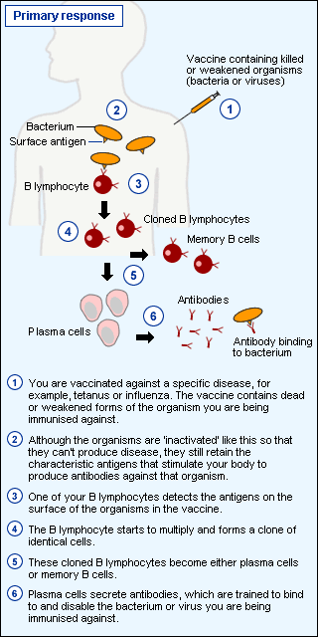

How does vaccination prevent disease?
The memory B cells (as the name implies) keep a memory of the organism that you were vaccinated against. If you are ever exposed to that organism, the dormant memory cells will recognise it straight away, and rapidly start multiplying and developing into plasma cells. Because the plasma cells have already been trained to produce antibodies against the organism, they are able to produce a large number of antibodies very quickly (within hours).
The antibodies attach to the invading organisms and prevent them from attacking your healthy cells. And because the antibodies are produced so quickly, they are able to fight the disease before you even get sick.
This accelerated and more intense immune response generated by the memory B cells is known as the secondary response. It is faster and more effective because all the preparations for the attack were made when you were vaccinated.
