Unit 6: M2 How does the immune system work?
Explain each component of the immune system (tonsils, thymus, lymph nodes/lymph system, bone marrow, spleen, white blood cells – both T and B types).

M2 Help sheet
M2: How does your immune system work?
Your immune system uses a huge army of defender cells - different types of white blood cell. You make about 1000 million of them every day in your bone marrow. Some of these cells, called macrophages, constantly patrol your body, destroying germs as soon as they enter. This is your 'natural' or inborn immunity. But if an infection begins to take hold, your body fights back with an even more powerful defence of T- and B-cells. They give you acquired immunity, so that the same germ can never make you as ill again.
What do T- and B-cells do?
T- and B-cells are highly specialised defender cells - different groups of cells are tailored to different germs. When your body is infected with a particular germ, only the T- and B-cells that recognise it will respond. These selected cells then quickly multiply, creating an army of identical cells to fight the infection. Special types of T- and B-cells 'remember' the invader, making you immune to a second attack.
How do you recognise invaders?
Your T- and B-cells recognise invaders by the shape of molecules - antigens - on their surfaces. Your immune system can produce a T- and B-cell to fit every possible shape. However, any T- or B-cell that recognised molecules found on your cells were destroyed while you were growing in the womb, to prevent them from attacking your own body. But you were left with millions of others, one for every foreign antigen you might ever encounter.
What is so special about your T-cells?
Having recognised the invader, different types of T-cell then have different jobs to do. Some send chemical instructions (cytokines) to the rest of the immune system. Your body can then produce the most effective weapons against the invaders, which may be bacteria, viruses or parasites. Other types of T-cells recognise and kill virus-infected cells directly. Some help B-cells to make antibodies, which circulate and bind to antigens.
What is so special about your B-cells?
With the help of T-cells, B-cells make special Y-shaped proteins called antibodies. Antibodies stick to antigens on the surface of germs, stopping them in their tracks, creating clumps that alert your body to the presence of intruders. Your body then starts to make toxic substances to fight them. Patrolling defender cells called phagocytes engulf and destroy antibody-covered intruders.
Source: http://www.sciencemuseum.org.uk/WhoAmI/FindOutMore/Yourbody/Whatdoesyourimmunesystemdo/Howdoesyourimmunesystemwork/WhatdoT-andB-cellsdo.aspx

Components of the Immune System
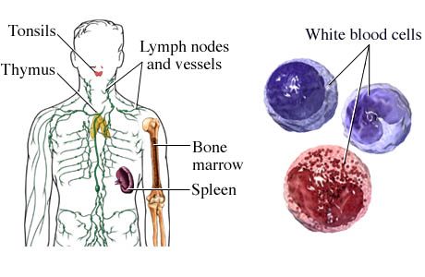
http://www.nucleusinc.com
The immune system is the body's natural defense system that helps fight infections. The immune system is made up of antibodies, white blood cells, and other chemicals and proteins that attack and destroy substances such as bacteria and viruses that they recognize as foreign and different from the body's normal healthy tissues. The immune system also includes:
- The tonsils and thymus, which make antibodies.
- The lymph nodes and vessels (the lymphatic system). This network of lymph nodes and vessels throughout the body carries lymph fluid, nutrients, and waste material between the body tissues and the bloodstream. The lymphatic system is an important part of the immune system. The lymph nodes filter lymph fluid as it flows through them, trapping bacteria, viruses, and other foreign substances, which are then destroyed by special white blood cells called lymphocytes.
- Bone marrow. This is soft tissue found mainly inside the long bones, vertebrae, and pelvic bones of the body. It is made up of red marrow, which produces red and white blood cells and platelets, and yellow marrow, which contains fat and connective tissue and produces some white blood cells.
- The spleen, which filters the blood by removing old or damaged blood cells and platelets and helps the immune system by destroying bacteria and other foreign substances.
- White blood cells. These blood cells are made in the bone marrow and protect the body against infection. If an infection develops, white blood cells attack and destroy the bacteria, virus, or other organism causing it.
Source: http://www.webmd.com/a-to-z-guides/components-of-the-immune-system

