BTEC Firsts (Level 2) in Applied Science

UNIT 3 ASSIGNMENT 2 – Criteria P2

Assignment Title: Classifying Organisms

Student Name: Teacher:

Date assignment issued: Final Completion Date:

Introduction

In order to finish this unit you need to complete 6 assignments in total. To make sure you finish on time and meet all your deadlines the assignment has been broken down into tasks and will be spaced over the course.

Each task will start with the part of the grading criteria that the task relates to, example P1, P2 or P3. It will finish with a deadline for the task to be completed by.

Overview:

Learners should be able to show characteristics by which organisms may be distinguished or grouped together using a variety of classification systems.

The learning outcomes for the unit:

To be able to investigate the classification of organisms.

Brief

You are working for a biological laboratory as a Science Technician. You need to create a classification key to help student volunteers classify organisms in a field survey of local habitats so that they can be counted.

Task

Construct simple identification keys.

Working on P2-  Grading Criteria:  “Construct simple identification  keys to show how variation  between species can be  classified.” | Create an identification key to allow identification of the major classification groups:  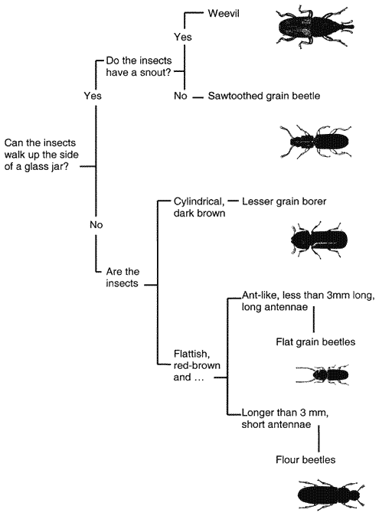  - Viruses  - Bacteria  - Protists  - Fungi  - Plants (flowering plants, non-flowering plants)  - Animals (invertebrates, vertebrates)  There must be a question at each branch.  Pick 5 organisms and create a second identification key.  Posters can be using ICT or hand drawn. | Deadline for Task:

Self Assessment Checklist

Task | What you will have produced | Deadline
linked  to P2 | - Create 2 identification keys to allow identification of the major classification groups and one other set of organisms  (IDENTIFICATION KEYS)

Resource list
Websites:  - www.bbc.bitesize.co.uk  - www.schoolscience.co.uk  - www.sciencemuseum.org.uk  - www.societyofbiology.org.uk  - www.practicalbiology.org | Text books  - Biology for you  - Edexcel 360 - Core and additional  - 21st Century Science Biology textbook

Final things:

  - Page number your portfolio (make sure it is all in the correct order)

  - Include a bibliography stating all your sources

  - Use appendices to store any additional information e.g. your screen dumps or newspaper articles

  - Make sure you create your own front cover with your name, the BTEC details and the unit details plus your teacher’s name.

