Unit 10: Assignment 5 Reproductive system Name: _________________________________

Merit 5 (M5) – Fertility hormones
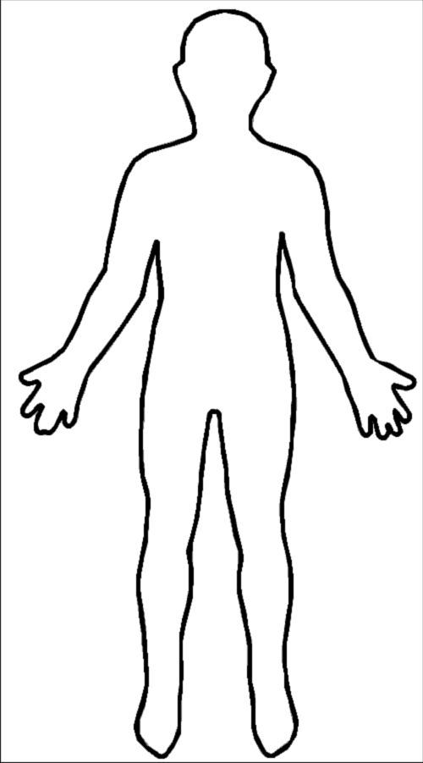
1) Label on here where Follicle Stimulating Enzyme (FSH) Oestrogen, Luteinising Hormone (LH) and Progesterone are produced by the woman’s body.

2) Complete this table:

Hormone | Produced by | Function
FSH
Oestrogen
LH
Progesterone

3) Why are hormones important for female fertility?
_____________________________________________________________________________
_____________________________________________________________________________
_____________________________________________________________________________
_____________________________________________________________________________
_____________________________________________________________________________
_____________________________________________________________________________

