Unit 10: Assignment 2 Body systems Name: ________________________

Merit 2 (M2) – Explain the way the respiratory and circulatory systems interact to maintain cellular and body function.

Image 1 | Image 2

How do the two interact?

________________________________________________________________________________________
________________________________________________________________________________________
________________________________________________________________________________________
________________________________________________________________________________________
________________________________________________________________________________________
________________________________________________________________________________________
________________________________________________________________________________________
________________________________________________________________________________________
________________________________________________________________________________________
________________________________________________________________________________________
________________________________________________________________________________________
________________________________________________________________________________________
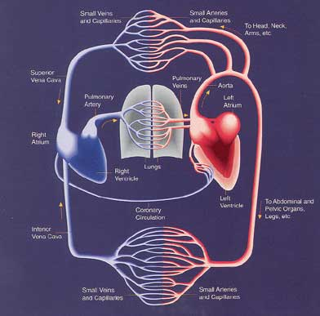 | 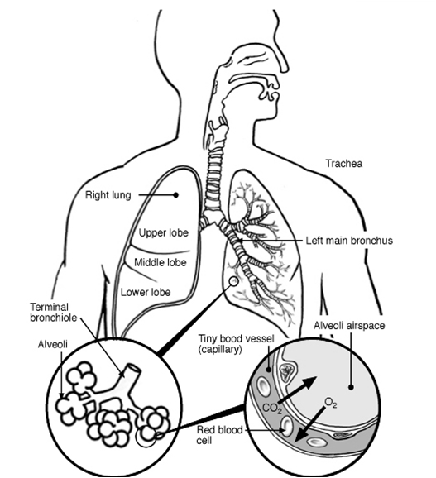

Help sheet:

How do the respiratory and circulatory systems work together?

Answer 1:
They work together by inhaling and exhaling . The heart pumps blood into the lungs where the blood is oxygenated. The blood is then returned to the heart and the newly oxygenated blood is circulated to the rest of the body. The respiratory system performs a process known as gas exchange that releases carbon dioxide from the body and brings in oxygen. This occurs in the lungs and the circulatory system then transports the oxygen to tissues that used internal respiration to burn fuel in the form of ATP (adenosine triphosphate) for energy, thus creating more carbon dioxide.
Source1: http://wiki.answers.com/Q/How_do_the_circulatory_and_respiratory_systems_work_together

Answer 2:
You breathe in oxygen into your lungs. The oxygen diffuses across the thin walls of the alveoli in the lungs and the thin walls of the blood vessels in the lungs into the blood stream. Here it attaches to the haemoglobin molecules inside red blood cells. The red blood cells are carried by the blood vessels to all parts of the body. The haemoglobin releases oxygen in the periphery, and picks up carbon dioxide (CO2). The CO2 attached to the haemoglobin molecules in the red blood cells is then transported to the lungs, where it diffuses across the walls into the alveoli, and is breathed out.
Source 2: http://wiki.answers.com/Q/How_do_the_circulatory_and_respiratory_systems_work_together

Additional information:
The heart pumps blood into the lungs where the blood is oxygenated. The blood is then returned to the heart and the newly oxygenated blood is circulated to the rest of the body.
The respiratory system performs a process known as gas exchange that releases carbon dioxide from the body and brings in oxygen. This occurs in the lungs and the circulatory system then transports the oxygen to tissues that used internal respiration to burn fuel in the form of ATP (adenosine triphosphate) for energy, thus creating more carbon dioxide.
They work hand in hand to provide the tissues of the body with oxygen. The respiratory system oxygenates the blood and the circulatory system sends it to the rest of the body.

