BTEC First Certificate (Level 2) in Applied Science
UNIT 6 ASSIGNMENT 3 – Medical Treatments

Student Name: Teacher:

Date assignment issued: Final Completion Date:

Introduction

In order to finish this unit you need to complete an assignment. To make sure you finish on time and meet all your deadlines the assignment has been broken down into tasks and will be spaced over the course.

Each task will start with the part of the grading criteria that the task relates to, example P1, P2. It will finish with a deadline for the task to be completed by.

The learning outcome for the unit:

- Understand different medical treatments

Brief

You are working with genetic counsellors and asked to prepare a portfolio of information which can be used to demonstrate balanced views of medical treatments to families who have concerns about gene therapy and admission into hospital.

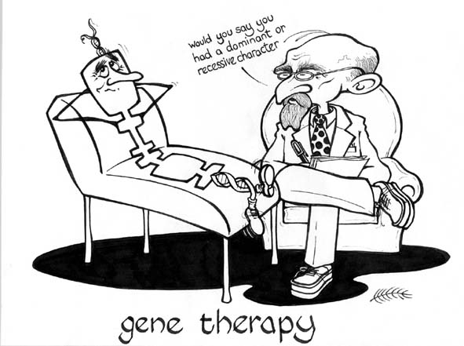

Task 1
Working on P5:  Carry out an investigation into the effects of antibiotics | - Carry out a practical to show what happens to the bacterial growth on an agar plate when antibiotics are added.  2. Write up your practical to show the effects of antibiotics  Add your write up to your portfolio | Deadline for Task 1:

Task 2
Working on P6:  Describe what gene therapy is, giving examples of diseases and conditions associated with it | Use your own research to produce a document which:  - Defines gene therapy  - Gives two examples of conditions which gene therapy is used to treat  Add your write up to your portfolio | Deadline for Task 2:

Task 3
Working on M4:  Using secondary data carry out an investigation into the effectiveness of different kinds of medical treatment in the control of health | Produce 3 documents.  Document 1: Write an answer to the question ‘how effective are antibiotics in treating illness?’  Document 2: Write an answer to the question ‘how effective is gene therapy for treating illness?’  Document 3: Write an answer to the question ‘how effective is the use of stem cells for treating illness?’  At the bottom of each document list all the resources you used to answer the questions. Your teacher may also provide you with some resources.  Add all 3 documents to your portfolio. | Deadline for Task 3:

Task 4
Working on D3:  Evaluate the use of different kinds of medical treatments, justifying your opinions | - Highlight the advantages and disadvantages of antibiotics  - Highlight the advantages and disadvantages of gene therapy  - Write a paragraph explaining whether you think antibiotics or gene therapy is the best option and justifying why. Remember to use evidence from your research in your justification. | Deadline for Task 4:

Self Assessment Checklist

Task | What you will have produced | Deadline
1 linked to P5 | - A portfolio including a write-up of the practical you have done on antibiotics or a report on your research  - Teacher observation record
2 linked  P6 | - Research on gene therapy, with 2 examples to add to your portfolio
3 linked  To M4 | Three documents showing the results of your investigation into the effectiveness of different kinds of medical treatments
4 linked to D3 | A chart showing the advantages and disadvantages of antibiotics and gene therapy as well as a paragraph evaluating their use.  Report, justification

Final things:

  - Page number your portfolio (make sure it is all in the correct order)
  - Include a bibliography stating all your sources
  - Use appendices to store any additional information e.g. your screen dumps or newspaper articles
  - Make sure you create your own front cover with your name, the BTEC details and the unit details plus your teacher’s name.

