Instructions:
Below are completed merit and distinction tasks for Unit 3: Biology.

You must use the tasks to write your own answer or put the answers in your own words.
Merits cannot be copied.

Merit and distinction tasks: D1
Working on  D1  Grading Criteria:  “Explain how genes control variation within a species brings about evolutionary change”. | Write a 500 word explanation of how genes control variation using a simple code which brings about an evolutionary change.  Include: the triplet code and how it leads to translation to produce a protein; how genes control variation within the species by linking the triplet code in DNA to the production of different proteins in cells.  E.g. – How have changes in genes in peppered moths allowed them to adapt to their environment?
D1: How genes control variation and can bring about evolutionary change

DNA is a chemical found in the chromosomes within the nucleus of almost all cells. Each gene codes for a particular characteristic. The DNA is a double-stranded molecule in a double helix. The double helix is made of nucleotide bases (thymine (T), adenine (A), guanine (G) and cytosine (C)) which join together to make a polynucleotide. The diagram shows how the nucleotide bases are arranged; A pairs with T, G pairs with C.
The pairs are held together by hydrogen bonds between the complementing base pairs.
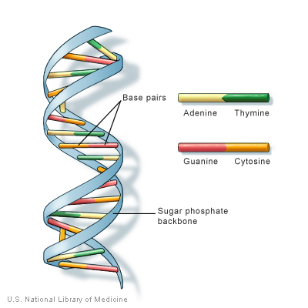
When a protein is required by the cell, DNA is translated to messenger RNA (mRNA) and this mRNA travels to a ribosome in the cytoplasm. In the ribosome, three bases are read as a codon. The ribosome holds the mRNA in place, and transfer RNA (tRNA) brings the building block of protein, amino acid, to the ribosome. Part of the tRNA molecule is the exact match for the codon, it is called an anticodon. When the tRNA anticodon matches with the mRNA codon, the amino acid is in the correct place and the protein begins to be made. Some codons code for the start or end for a protein; an exactly correct order of amino acids is required for the protein to be produced correctly.

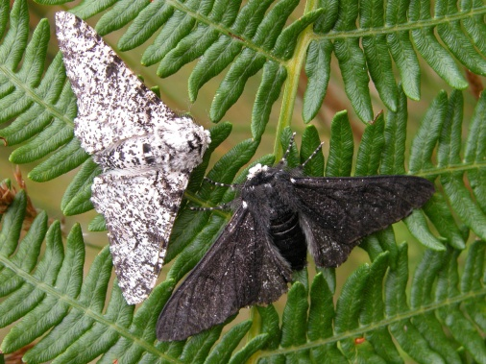
Different genes will code for different proteins. Mutations or changes in DNA will result in the cell, and therefore the organism, displaying different characteristics. The evolution of the peppered moth over the last two hundred years has been studied in detail. Originally, the vast majority of peppered moths had light colouration, which effectively camouflaged them against the light-coloured trees and lichens which they rested upon. However, because of widespread pollution during the Industrial Revolution in England, many of the lichens died out, and the trees that peppered moths rested on became blackened by soot, causing most of the light-coloured moths to die off from predation. At the same time, the dark-coloured moths, flourished because of their ability to hide on the darkened trees.

The genes for dark colouration were not favourable before the industrial revolution, as the moths that displayed them would have been easily spotted and therefore eaten. Therefore, by natural selection, these moths were killed. However, as the industrial revolution covered many areas with soot, the genes for dark colouration were favoured and genes for light colouration became unfavourable. As the DNA of these moths was different, the gene for dark skin/cell pigmentation was transcribed to protein in the process described above, and the moth skin/cells became dark. If these dark moths were the only ones to proliferate through the white moths being eaten, these moths would evolve with only a dark colouration.

Working on M1-  Grading Criteria:  “Describe how variation  within a species brings about  evolutionary change” | Produce a poster to show how variation brings about evolutionary change.  Choose two organisms such as an animal or a plant and then create a poster, Include images to describe how variation within a species brings about evolutionary change.  E.g. how a camel has a developed long eye lashes to protect their eyes from sand and the other genetic variation?  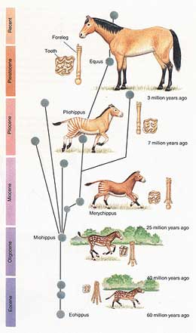  E.g. how the organism has mutated?  E.g. why did all the short neck giraffes die out?  You may decide to choose the Peppered Moth – it’s a great example. How did changes in the environment lead to one variation of the moth (the Black variety) increasing in number? How does this show how variation can bring about evolutionary change?
M1: How variation within a species brings about evolutionary change
Peppered moths
The evolution of the peppered moth over the last two hundred years has been studied in detail. Originally, the vast majority of peppered moths had light colouration, which effectively camouflaged them against the light-coloured trees and lichens which they rested upon. However, because of widespread pollution during the Industrial Revolution in England, many of the lichens died out, and the trees that peppered moths rested on became blackened by soot, causing most of the light-coloured moths to die off from predation. At the same time, the dark-coloured moths, flourished because of their ability to hide on the darkened trees.
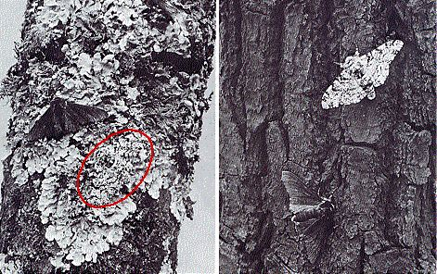
It was favourable for the moths to have a colour that matched their background, and in this way the species evolved to adapt to the change in environment.

Cacti evolution of spines
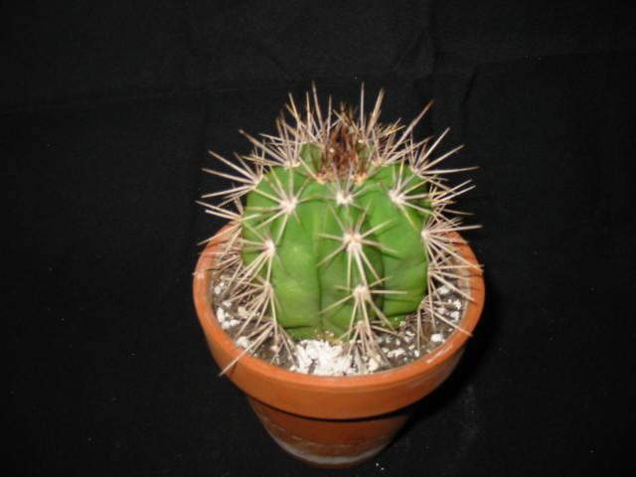
One defining feature of cacti is having clusters of spines, instead of leaves. Numerous plants have spines, but in cacti, spines occur in clusters in the axil of leaves, even though the leaves are usually microscopic. Most cactus morphologists have concluded that cactus spines are either modified leaves or modified bud scales. The spines evolved through mutations in DNA which resulted in leaves becoming more spine-like. The result of sharper leaves (spines) is that less predators could eat the plants. As these plants had a greater chance of survival, they passed on their genes on to the following generation. The combination of the benefits of spines and those cacti with leaves instead of spines being at a distinct disadvantage, resulted in the proliferation of spiny cacti.

Working on M2-  Grading Criteria:  “Explain how organisms within  an ecosystem interact over  time.” | For the example in task 1 how are the foxes dependant on the number of rabbits and how are their numbers affected by the population of squirrels and mice?  What happens when numbers of rabbits increase?  Why?  Draw and explain a graph to show the predator-prey cycle over time.
M2: How organisms within an ecosystem interact over time
The first part of M2 is included during P2 – the food chains pass task.
As the number of foxes increases, the number of rabbits decreases, as the foxes will eat more of the rabbits. This will result in an increase in the amount of grass, as there are less rabbits.
If the number of rabbits increases, the number of foxes will increase as there is more food for them to eat. This will also result in a decrease in the amount of grass, which is eaten by rabbits.

Graph of predator-prey cycle over time:

The predator-prey cycle looks like this, as the number of predators increases, the number of prey decreases. The result of lots of predators is that there is only a little prey. The foxes cannot live sustainably with only a little food, and therefore the number of foxes reduces. As the number of foxes decreases, the rabbits can multiply. When the prey number is high, the predator number begins to increase, as the predators now have plentiful food. This cycle continues for ever, until there is a disruption of the food chain.

Working on  M3  Grading Criteria:  “Describe how to measure the effect of human activity on an environment”. | Create a report to describe how to measure the effects of human activity on a lake. For example, you could choose to look at a lake and research the ways in which it is being affected by humans. This could include:  - Water Pollution (factories etc)  - Fishing  - Noise pollution  - Loss of habitat  Then describe, in your report, how you could measure the impact of each of these.
M3: Describe how to measure the effect of human activity on an environment
Humans can have a number of effects on a lake. Factories can pump unused or waste chemicals into the lake as a method of disposal. Boats or other industrial processes can release waste fuel and gas into the lake. If near farmland, fertilisers may run-off into the lake from fields. The result of this run-off is eutrophication: the fertilisers cause an overproduction of algae on the surface; the algae block much of the sunlight from the lake and cause death of lake plants below; the algae also die and all matter is broken down by bacteria; the bacteria use oxygen in respiration and therefore reduce the oxygen level in the lake; the reduced oxygen content results in the death of organisms that live in the lake. The result of this is poisoning of the water; many aquatic life and life around the edge of the lake may die. Sewage may also be pumped into the lake, which may have the effect of eutrophication or poisoning. Over fishing can cause severe disruption of food chains and a decrease in the population of fish. Noise pollution can disrupt the lives of animals that live in the lake. Noise pollution may come from nearby industrial work or recreational activities (speed boats).

The impact of these activities could be measured by:
- Monitoring oxygen levels in the water – if oxygen level decreases too much then it will be unsafe for fish to live.
- Noise indicators (microphones) could be stationed at the edges of the lake and set up to monitor the noise level.
- pH indicators can be used to measure the pH of the water in different areas.
- Numbers of fish can be measured to ensure overfishing is not a problem.
- Visual surveys of the banks around the lake can be used to check for sewage/chemical dumping.

Working on D2-  Grading Criteria:  “Explain how the environmental effect of human activity might be minimised in the future” | For the given environment, put together a hyperlinked presentation to explain how the impact of humans could be reduced.  For each of the human impacts in M3, describe how they could be reduced. You must try to give more than one way in which they could be reduced- think of alternatives ways to reduce the impact, not just the first thing that comes to mind.

Working on  M4-  Grading Criteria:  “Explain how selected medical, social and inherited factors disrupt body systems to cause ill health”. | For each of the factors described in P5, make a large flash card/top trump card to explain HOW the body/human health is affected by it.  For example, if you described a micro-organism that infects the body and leads to ill health, explain how it achieves this, e.g. What cells does it infect? What is the effect of infection? How is the body or health harmed? What is the explanation of the biology behind it?
M4: Explain how selected medical, social and inherited factors disrupt body systems to cause ill health

Medical factor
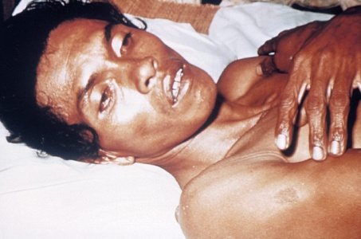
Bacterial infection by pathogenic bacteria. Cholera is a disease that causes extreme diarrhoea and sickness due to the large numbers of toxins produced by bacteria. Cholera is an infection of the small intestine cells by the bacterium Vibrio cholerae. The cholera bacteria survive the acidic stomach, and proliferate in the small intestine. The CTX toxin produced by the cholera bacteria results in an inability to resorb water, and therefore severe dehydration results (up to 2 litres per hour is lost). If the severe diarrhea is not treated with intravenous rehydration, it can result in life-threatening dehydration. The typical symptoms of dehydration include low blood pressure, poor skin turgor (wrinkled hands), sunken eyes and a rapid pulse.

Social factor
Cannabis is a depressant hallucinogen, which can cause mental health problems such as schizophrenia. Cannabis affects the nervous system, and has psychoactive and physiological effects when consumed. Some alternative media sources report that minimum amount of tetrahydrocannabinol (THC) required to have a perceptible psychoactive effect is about 10 micrograms per kilogram of body weight.
Medically, cannabis has been used as an analgesic (a pain reliever), and has shown limited therapeutic benefit in treating neurological illnesses such as epilepsy and bipolar disorder. The THC binds to cannabinoid receptors in the brain. Long term use of cannabis has been shown to induces hallucinogenic and schizophrenic symptoms in people.

Inherited factor
Cystic fibrosis is an inherited condition where large amounts of sticky mucus build up in the airway and digestive tract. Symptoms include a persistent cough, regular chest infections and long-lasting diarrhoea. The name cystic fibrosis refers to the characteristic scarring (fibrosis) and cyst formation within the pancreas. Difficulty breathing is the most serious symptom and results from frequent lung infections that are treated with antibiotics and other medications. Other symptoms, including sinus infections, poor growth, and infertility affect other parts of the body.

CF is caused by mutations in the CFTR gene. The faulty CFTR gene may produce a protein that is misfolded in translation. The misfolded protein causes abnormal transport of chloride and sodium across an epithelium, leading to thick, viscous secretions that clog the airway and digestive tract.
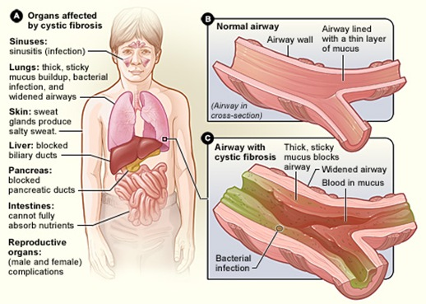

Working on D3-  Grading Criteria:  “Describe the social issues which arise as a result of the selected medical, social and inherited factors and the illnesses they cause” | For each of the factors which you have explained in M4, describe the social issues which they cause in a leaflet.  You need to describe the social issues which are caused by the factors that you have explained in P5 and M4.  For example, if you explained the effect of smoking on the body, now describe the social issues related to it. These may include:  - How it affects relationships in marriages/families and the communities  - How it causes additional expense to medical services, or other social services  - How it affects society as a whole- what are the negative effects on other people?  - What knock on problems it causes to other people- e.g. for drug use this could be crime/violence/accidents etc  Present your findings as leaflet on the social issues caused by factors affecting human health.

