BTEC Firsts (Level 2) in Applied Science
UNIT 2 - Energy and Our Universe
ASSIGNMENT 2 – Applications of Waves and Radiation

Student Name: Teacher:

Date assignment issued: Final Completion Date:

Introduction

In order to finish this unit you need to complete an assignment. To make sure you finish on time and meet all your deadlines the assignment has been broken down into tasks and will be spaced over the course.

Each task will start with the part of the grading criteria that the task relates to, example P1, P2. It will finish with a deadline for the task to be completed by.

The learning outcomes for this assignment:

- Know the properties and applications of waves and radiation

Brief

You are a trainee scientist who is looking at different types of wave and radiation and their applications in society.

You will need to prepare a report/presentation from research findings.

You will need to focus on:

- Identifying different types of waves and their characteristics.
- How different types of waves travel in different materials.
- How waves can be used for communication.
- How the three types of ionising particles affect matter.

Task 1
a)- Poster
Working on  P3 Describe the electromagnetic  Spectrum  P4  Describe the different types of  radiation, including non-ionising  and ionising radiation | Research for information on the electromagnetic spectrum including the main characteristics.  Include:  - Labels of each part of the EM spectrum in order  - Wavelengths  - Uses  - Dangers  Use your research to produce a poster (ICT or hand drawn) make sure you include diagrams.  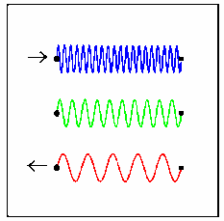  You may want to set out your information as a table.  In particular, research information and images on the different types of non-ionising radiation  - Microwave  - Infrared  - Radio waves | Deadline for Task 1a:

Task 2
Working on  P5 Describe how waves can be used for communication | Research information on different types of waves used for communication including their main characteristics. Remember to cover:  - The Electromagnetic Spectrum  - Light waves  - Sound waves  Use your research to produce a presentation describing how waves can be used for communication.  Remember to include diagrams and characteristics of all the waves stated above.  This presentation covers P5, M3 and D3 depending how much  detail you include  This will be assessed through an oral presentation to the  teacher and another group of students.  You need to hand in your notes for your talk.  Your teacher/peers will use an observation checklist to support  your work. | Deadline for Task 2a:
a)- Presentation

Working on  M3  Explain the advantages of  wireless communication | Using the information collected in task 2a and further research add to your presentation slides to explain how we use waves for wireless communications.  Include the advantages of wireless communication.  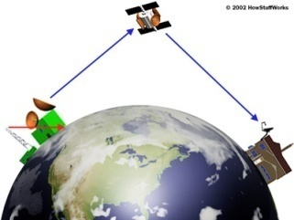 | Deadline for Task 2b:
b)- Presentation continued..

Working on  D3  Compare wired and  wireless communication  systems | Finally add to your presentation slides that compare wireless communication to wired communication. Think about the advantages and disadvantages for both.  Remember:  Wireless communication; common uses, e.g. radio, mobile phones, computers with Wi-Fi connection;  Wired communication, eg telephone networks, cable television, fibre-optics. | Deadline for Task 2c:
c)- Presentation continued...

Task 3
a)-Poster
Working on  P4  Describe the different types of  radiation, including non-ionising  and ionising radiation | Research information and images on the different types of ionising radiation  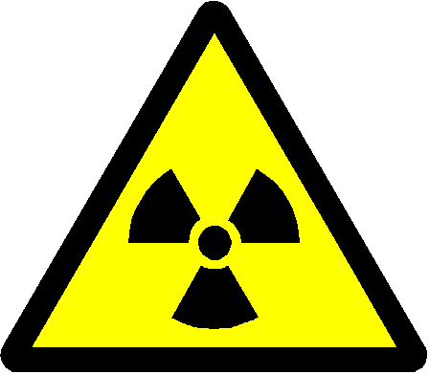  - Alpha  - Beta  - Gamma  Include: Penetrating power; effect in a magnetic field; ionising ability  Produce a series of A4 Posters to show the different types of ionising radiation shown above and their main properties. | Deadline for Task 3a:

b)- Poster continued..
Working on  M2  Describe the uses of  ionising and non-ionising  radiation are used in the  home or workplace | Add to your posters of ionising and non-ionising radiation in 3a their uses in the home or the workplace.  non-ionising radiation, e.g. microwaves, infrared, radiowaves;  ionising radiation, e.g. alpha, beta and gamma rays | Deadline for Task 3b:

c)- Leaflet
Working on  D2  Discuss the possible  negative effects of ionising and non-ionising radiation | Research the effects of the ionising and non-ionising types of radiation mentioned in task 3a & 3b on organisms and their environment.  Produce a leaflet informing people of their negative effects.  Think about:  What effect can ionising and non-ionising radiation have on humans?  What effects can they have on the environment? | Deadline for Task 3c:

Self Assessment Checklist

Task | What you will have produced | Deadline
1a linked  to P3 | - A poster describing the main characteristics of the electromagnetic spectrum.  (POSTER)
2a,2b, 2c linked  To P5, M3 and D3 | - A presentation describing how waves can be used for communication.  - Explain the advantages of wireless communication.  - Compare the wireless and wired communication. Think about the advantages and disadvantages for both.  (PRESENTATION)
3a, 3b, 3c linked  to P4, M2 and D2 | - A poster describing the different types of radiation, ionising, and non-ionising (look at their main properties).  - Add to your poster the uses in the home and at the workplace for the different types of radiation.  - A leaflet looking at the possible negative effects of radiation, ionising and non-ionising.  (POSTER, LEAFLET)

Final things:

  - Page number your portfolio (make sure it is all in the correct order)
  - Include a bibliography stating all your sources
  - Use appendices to store any additional information e.g. your screen dumps or newspaper articles
  - Make sure you create your own front cover with your name, the BTEC details and the unit details plus your teacher’s name.

