Unit 10: Assignment 1 Enzymes Name: ________________________

Merit 1 (M1) – How is the action of enzymes controlled by different conditions?

Condition | How it affects enzyme action
Temperature | _______________________________________________________________________  _______________________________________________________________________  _______________________________________________________________________  _______________________________________________________________________  _______________________________________________________________________  _______________________________________________________________________  _______________________________________________________________________  _______________________________________________________________________
Substrate concentration | _______________________________________________________________________  _______________________________________________________________________  _______________________________________________________________________  _______________________________________________________________________  _______________________________________________________________________  _______________________________________________________________________  _______________________________________________________________________  _______________________________________________________________________
pH | _______________________________________________________________________  _______________________________________________________________________  _______________________________________________________________________  _______________________________________________________________________  _______________________________________________________________________  _______________________________________________________________________  _______________________________________________________________________

Help sheet:
How temperature affects enzyme action

Generally speaking heating up a chemical reaction makes it go quicker. This is because chemicals need energy in order to react, heat them up and a greater proportion of the chemicals have the right amount of energy needed to react. Also the hotter the chemicals are the faster their particles move around. This increases the chances of chemicals colliding and collisions between particles are needed for chemical reactions to take place.
Enzymes though are sensitive to extreme heat. They are very large proteins whose three dimensional shape is vital for their activity. When proteins are heated up too much they vibrate. If the heat gets too intense then the enzymes literally shake themselves out of shape. The enzyme is said to be denatured. Enzymes generally become denatured when heated above 40ºC. The optimum temperature for enzymes to work at is around 37ºC which is why this temperature is body temperature. Temperatures lower than optimum mean the chemical reaction will be slower for the reasons stated above.
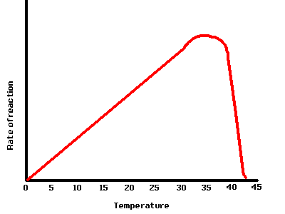

How pH affects enzyme action

Enzymes are also sensitive to changes in pH. The protein chain the enzyme molecule is made from is coiled and folded into a very specific shape. This shape is held together by the attraction between positive & negative charges on different parts of the molecule. The pH of the surrounding environment can affect the charges on the enzyme molecule, causing them to be changed. This can cause the protein chain to unfold or uncoil. Even a slight change in an enzyme molecule's shape can prevent it from working properly. This change of shape is called denaturing.
Most enzymes work best at a pH around neutral. Changing the pH by just one unit either way will usually prevent and enzyme from working. Amylase works best at a pH of around 7.5, so placing it in a solution greater than pH8.5 or lower than pH6.5 will prevent it from working at all. Some enzymes work at extreme pH levels. Pepsin, an enzyme found in gastric juice in the stomach, works best at pH 2.

Source: http://learning.royallatin.bucks.sch.uk/mod/resource/view.php?id=1846

How substrate concentration affects enzyme action

When substrate concentration increases, enzyme activity increases. This is due to the increased amount of substrate in one place so it is more likely that a substrate molecule and enzyme collide. More successful collisions will occur, higher rate of reaction.

At low substrate concentration enzyme activity is directly proportional to substrate concentration. At high concentrations all the active sites of the enzyme are fully occupied and made the substrate abundant This mean that the enzyme is more active when the substrate concentrations is at the high level. But till certain level when the substrate concentrations are high enough the reaction rate become constant as all the active sites are fully occupied.

At low substrate concentration, enzyme activity is proportional to substrate concentration .This is because random collision between substrate and active site happen more frequently with higher substrate concentrations.
At high substrate concentrations, all the active sites of the enzyme are fully occupied, so raising the substrate concentration has no effect.

