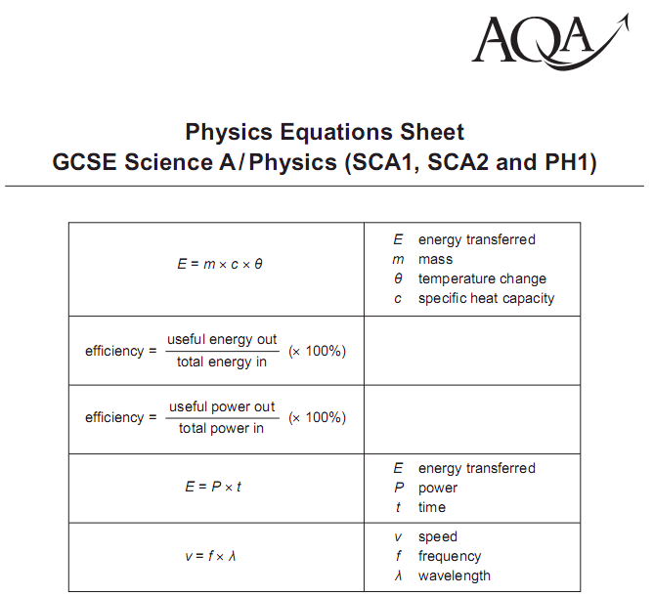
P1 Physics Equation Practice

Specific Heat Capacity
Q1. How much energy is needed to raise the temperature of a 1 kg block of steel from 15ºC to 40ºC? The specific heat capacity of steel is 230 J/kg/ºC.
Q2. How much energy is needed to raise the temperature of a 2 kg block of lead from 25ºC to 50ºC? The specific heat capacity of lead is 130 J/kg/ºC.

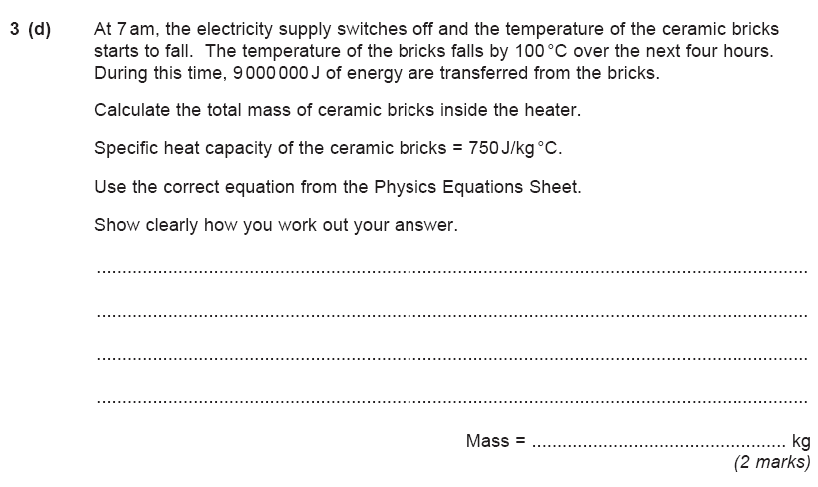
Specific Heat Capacity
Answers:
Q1. Correct equation from data sheet: E = m x c x θ
M = 1 kg c = 230 J/kg/ºC θ = 40ºC
E = m x c x θ E = 1 x 230 x 40 E = 9200 J
Q2. Correct equation from data sheet: E = m x c x θ
M = 2 kg c = 130 J/kg/ºC θ = 50 ºC – 25 ºC = 25ºC
E = m x c x θ E = 2 x 230 x 25 E = 11500 J or 11.5 kJ
3d) 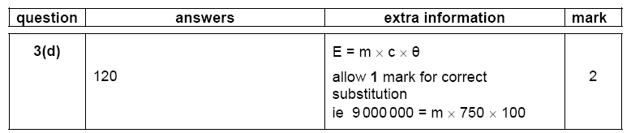

E = p x t Calculations
Easy (GRADE C) | Medium (GRADE B) | Hard (GRADE A/A*)
Write the equation to calculate energy transfers from power and time. | What is the energy transferred to a microwave oven if left on for 4 min drawing a power of  50 W? | What is the cost of a light bulb using energy of 10 kWh if the cost of electricity is 8 p and it is left on for 5 h?
What is the unit of power? | How long is a hair dryer left on for if the power drawn is 89 W and the energy transferred  50 J? | When James left the computer on all day (24 h), which transferred energy at a rate of 10 kWh and energy cost £1.50 per kWh why was she upset?
Rearrange the equation for power. | What is the energy transferred to an oven if left on for 1 hour drawing power of 40 kW? | Paul used his x-box for 3 hours every day 7 days a week. The x-box transfers 7kWh and energy was 20 p per hour. What is the cost of using the x-box?
Rearrange the equation for time. | What is the energy transferred to a kettle if it takes 5 min to boil and draws a power of 60 kW? | Lizzie dries her hair every day. The hair drier transfers energy at 5kWh. It takes her 20 min to dry her hair and electricity is 50 p per kWh. How much does this cost per week?
If an electrical appliance is on for 59 s and it draws 60 W what is the energy transferred? | What is the power if the energy transferred is 7000 J and the time is 80 min? | Make up your own question and swap with a partner.
If an electrical appliance is on for 116 s and draws 80 W what is the energy transferred? | What is the energy transferred if the heater is left on for 4 h and uses a power of 2 kW? | Make up your own question and swap with a partner.
If the energy transferred is  80 J and the appliance is left on for 90 s what is the power? | What is the cost of a washing machine using 6 kWh, if 1 kW hour is 10 p and it is left on for 4 hours? | Make up your own question and swap with a partner.
How long is the appliance on for if the energy transferred is 6 J and the power drawn is 1 W? | What is the cost of an iron using 5 kWh if 1 kW is 30 p and Mum does the ironing for 10 h? | Make up your own question and swap with a partner.

Efficiency Calculation Questions

Efficiency (%) = Useful Energy Out x 100
Total Energy In

Higher Questions
1. Calculate the efficiency of a light bulb that gives of 40J of light from 200J of electrical energy.

2. Calculate the percentage efficiency of a motor that does of 60J of work from 240J of electrical energy.

3. Calculate the efficiency of a radio that gives of 30J of sound from 360J of electrical energy.

4. Calculate the efficiency of a runner who produces of 500J of kinetic energy from 2500J of chemical energy.

5. Calculate the percentage efficiency of a student who takes 2 hours to do 30 minutes of homework.

6. What is the useful light output from a bulb of efficiency 0.25 when supplied with 600J of energy?

7. What is the useful work output from a motor of efficiency 0.60 when supplied with 1200J of energy?

8. What is the useful sound output from a radio of efficiency 50% when supplied with 20J of energy?

9. What is the useful work done by a runner of efficiency 0.30 when supplied with 200J of energy?

