C1 Revision Booklet 2012

Try to complete all of the activities in the booklet – if you get stuck: use your syllabus, revision guides, text books and the internet to help you. If you are still unable to find out then ask me when I get back (or another science teacher).
Remember that YOU are responsible for your own revision – this booklet should be supplemented by other revision too. The more of this booklet you complete, the better prepared you will be for your exam.
Good Luck
Miss Hands

Name _______________________________________________
C1.1 The fundamental Ideas in Chemistry
C1.1.1 Atoms
What is an atom?
………………………………………………………………………………………………………………………………………………………………………………………………………………………………………………………………
What is an element?
………………………………………………………………………………………………………………………………………………………………………………………………………………………………………………………………
Indicate where you would find metals and non-metals:
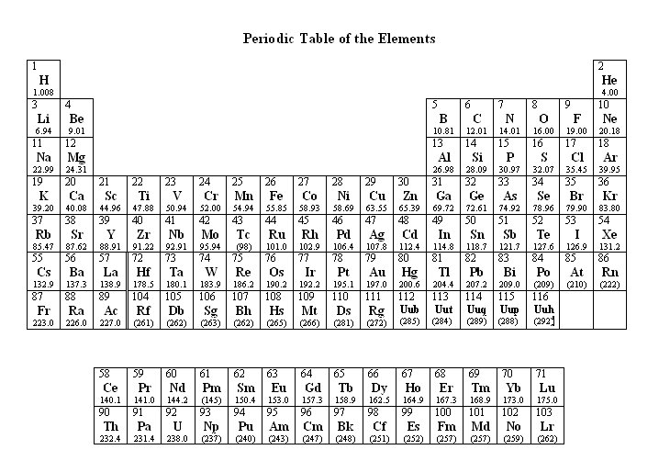
Match the name of the element with the symbol
Element | Symbol
Oxygen
Sodium
 | H
 | Li
Copper
Potassium
 | Ar
 | Ca

Draw and label the structure of an atom. Ensure that you include the following key words:
Nucleus Protons Neutrons Electrons

Complete the table below
Name of Particle | Charge | Mass
Proton
Neutron
Electron

Explain why atoms have no overall electrical charge.
………………………………………………………………………………………………………………………………………………………………………………………………………………………………………………………………
What does the atomic number tell you?
………………………………………………………………………………………………………………………………………………………………………………………………………………………………………………………………
What does the mass number tell you?
………………………………………………………………………………………………………………………………………………………………………………………………………………………………………………………………

Complete the table
Element | Symbol | Atomic Number | Mass Number | Number of Protons | Number of Neutrons | Number of Electrons
Hydrogen
 | He
 |  | 3
 |  |  | 9
 |  |  |  | 5

Draw diagrams to show the electronic structure of the elements above. You should use 2 different methods of representing the electron arrangement.
For example:
Carbon
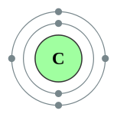 (2,4)

Describe the structure of an atom (6 marks)
…………………………………………………………………………………………………………………………………………………………………………………………………………………………………………………………………………………………………………………………………………………………………………………………………………………………………………………………………………………………………………………………………………………………………………………………………………………………………………………………………………………………………………………………………………………………………………………………………………………………………………………………………………………………………………………………………………………………………………………………………………………………………………………………………………………………………………………………………………………………………………………………………………………………………………………………………………………………………………………………………………………………………………………………………………………………………………………………………………………………………………………………………………………………………………………………………………………………………………………………………………………………………………………………………………………………………………
C1.1.2 The Periodic Table
Complete the table
Group Number | Number of Electrons in Outer Energy Level (Shell)
1
2
3
4
5
6
7
0

Using information in the table above, explain why elements in the same group of the periodic table have similar properties
………………………………………………………………………………………………………………………………………………………………………………………………………………………………………………………………

Label each of the group of the periodic table below. You may colour each group a different colour to show where they are.
The elements in group 0 (the noble gases) are very unreactive, explain why.
………………………………………………………………………………………………………………………………………………………………………………………………………………………………………………………………

C1.1.3 Chemical Reactions
For each chemical reaction:
- Write the word equation
- Colour the reactants in one colour and the products in another
- Identify how many of each element there is in each compound

Example
HCl + NaOH H₂O + NaCl
2 Hydrogens
1 Sodium
1 Chlorine
1 Sodium
1 Hydrogen
1 Hydrogen
1 Oxygen
1 Oxygen
1 Chlorine

Word Equation:
Hydrochloric acid + Sodium Hydroxide Water + Sodium Chloride

CaCO₃ CaO + CO₂

Word Equation:

Zn + H₂SO4 H₂ + ZnSO₄
Word Equation:

Mg + HCl MgCl + H₂
Word Equation:

PbO + C Pb + CO₂

Word Equation:

- Extension: Balance the symbol equations (Higher tier only)

What is a compound?
………………………………………………………………………………………………………………………………………………………………………………………………………………………………………………………………
What is an ion?
………………………………………………………………………………………………………………………………………………………………………………………………………………………………………………………………
What type of bonding occurs between:
Metal and non-metals?
……………………………………………………………………………………Two non-metals?
……………………………………………………………………………………
Complete the table about forming ions:
Metal/Non-metal | Gain/Loose Electrons? | Positive/Negative Ion?
Metal
Non-Metal

Draw a diagram showing the bonding between sodium and chlorine to form sodium chloride.

Draw a diagram to show how hydrogen and chlorine bond together to form HCl.

Complete the table, calculate the mass in each case.
Reactants |  | Products
Hydrochloric acid  20g | Sodium Hydroxide  20g | Sodium Chloride  10g | Water  ………..g
Calcium Carbonate  …………..g |  | Calcium Oxide  10g | Carbon dioxide  15g
Zinc  10g | Sulfuric Acid  ………g | Hydrogen  20g | Zinc Sulfate  10g
Magnesium  12g | Hydrochloric Acid  17g | Hydrogen  …….….g | Magnesium Chloride  15g
Lead Oxide  …………g | Carbon  14g | Carbon Dioxide  23g | Lead  12g

C1.2 Limestone and Building Materials
C1.2.1 Calcium Carbonate
What is limestone made from?
………………………………………………………………………………………………………………………………………………………………………………………………………………………………………………………………
How do you get limestone out of the ground?
………………………………………………………………………………………………………………………………………………………………………………………………………………………………………………………………
What is limestone used for?
………………………………………………………………………………………………………………………………………………………………………………………………………………………………………………………………
What is thermal decomposition?
………………………………………………………………………………………………………………………………………………………………………………………………………………………………………………………………

Write the word and symbol equations for the thermal decomposition of calcium carbonate.
………………………………………………………………………………………………………………………………………………………………………….
What happens to magnesium carbonate, copper carbonate, zinc carbonate and calcium carbonate when they are heated?
………………………………………………………………………………………………………………………………………………………………………………………………………………………………………………………………
Give a reason why not all of the above reactions could be observed in a classroom?
………………………………………………………………………………………………………………………………………………………………………………………………………………………………………………………………
Write word and symbol equations to show what happens when calcium oxide reacts with water. What can the product be used for?
………………………………………………………………………………………………………………………………………………………………………………………………………………………………………………………………

How do you test for the presence of carbon dioxide? Draw a diagram and write a description.

………………………………………………………………………………………………………………………………………………………………………………………………………………………………………………………………
What is the chemical name and formula for lime water?
…………………………………………………………………………………………………………………………………………………………………………
Describe the reaction that occurs when limewater reacts with carbon dioxide.
………………………………………………………………………………………………………………………………………………………………………………………………………………………………………………………………

What are the products produced when a carbonate reacts with an acid?
- ……………………………………………………………………………
- ……………………………………………………………………………
- ……………………………………………………………………………
What happens to limestone statues when exposed to acid rain?
………………………………………………………………………………………………………………………………………………………………………………………………………………………………………………………………

Complete the following:
Limestone + Heat + Clay = ……………………..
Cement + Sand = …………………..
Cement + Sand + Aggregate = ……………………………..

Discuss the advantages and disadvantages associate with limestone quarries. You will need to consider environmental, social and economic factors. (6 marks)
………………………………………………………………………………………………………………………………………………………………………………………………………………………………………………………………………………………………………………………………………………………………………………………………………………………………………………………………………………………………………………………………………………………………………………………………………………………………………………………………………………………………………………………………………………………………………………………………………………………………………………………………………………………………………………………………………………………………………………………………………………………………………………………………………………………………………………………………………………………………………………………………………………………………………………………………………………………………………………………………………………………………………………………………………………………………………………………………………………………………………………………………………………………………………………………………
C1.3 Metals and Their Uses
C1.3.1 Extracting Metals
What is an ore?
………………………………………………………………………………………………………………………………………………………………………………………………………………………………………………………………
Explain why it is possible to find gold in the Earth as a metal.
………………………………………………………………………………………………………………………………………………………………………………………………………………………………………………………………
What does the reactivity series show us?
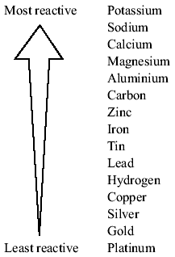
………………………………………………………………………………………………………………………………………………………………………………………………………………………………………………………………………………………………………………
How can carbon be used to extract a metal from its ore?
………………………………………………………………………………………………………………………………………………………………………………………………………………………………………………………………
What method do we use to extract more reactive metals such as aluminium?
………………………………………………………………………………………………………………………………………………………………………………………………………………………………………………………………
Why is aluminium expensive?
………………………………………………………………………………………………………………………………………………………………………………………………………………………………………………………………

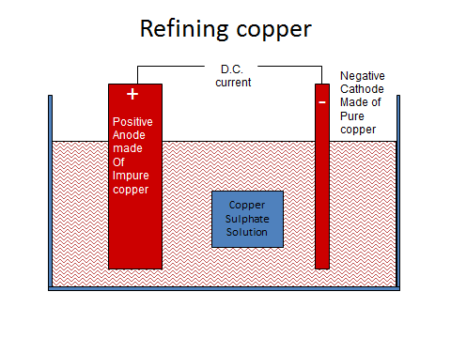
Add the following statements to the correct place on the diagram above

- Copper atoms lose electrons and become copper ions.
- The positive ions drift away from the anode
- Cu²⁺ + 2e- Cu
- Positive copper ions drift to the cathode.
- The cathode is electroplated
- Cu Cu²⁺ + 2e⁻
- The anode dissolves
- Copper atoms gain electrons and become copper atoms
Define the following words:
Phytoming ………………………………………………………………………………………………………………………………………………………………………….
Bioleaching ………………………………………………………………………………………………………………………………………………………………………….
Why are these processes important?
………………………………………………………………………………………………………………………………………………………………………………………………………………………………………………………………
List methods of extracting copper:
- …………………………….
- …………………………….
- …………………………….
- …………………………….

Why is it important that we recycle metals?
………………………………………………………………………………………………………………………………………………………………………………………………………………………………………………………………………………………………………………………………………………………………………………………………………………………………………………………………………………………………………………………………
C1.3.2 Alloys
What impact do impurities have on the properties of iron when it comes from the blast furnace?
………………………………………………………………………………………………………………………………………………………………………………………………………………………………………………………………
What is steel?
………………………………………………………………………………………………………………………………………………………………………………………………………………………………………………………………
Complete the table
Properties of high carbon steel | Properties of low carbon steel

Why do we convert copper, gold, iron and aluminium into alloys?
………………………………………………………………………………………………………………………………………………………………………………………………………………………………………………………………
C1.3.3
Colour in the transition metals
List properties of transition metals
………………………………………………………………………………………………………………………………………………………………………………………………………………………………………………………………

Complete the table
Metal | Properties | Uses
Copper
Aluminium
Titanium

C1.4 Crude Oil and Fuels
C1.4.1 Crude Oil
What is crude oil?
………………………………………………………………………………………………………………………………………………………………………………………………………………………………………………………………
Use diagrams to show how crude oil was formed.

What is a mixture?
………………………………………………………………………………………………………………………………………………………………………………………………………………………………………………………………
What is a hydrocarbon?
………………………………………………………………………………………………………………………………………………………………………………………………………………………………………………………………
Name a saturated hydrocarbon
…………………………………………………………………………………….
Give the general formula of an alkane
…………………………………………………………………………………….
C1.4.2 Hydrocarbons
Complete the following table
Alkane | Number of Carbons | Number of Hydrogens | Formula | Structure
 | 1
 |  | 6
 |  |  | C₃H₈
Butane |  |  |  | 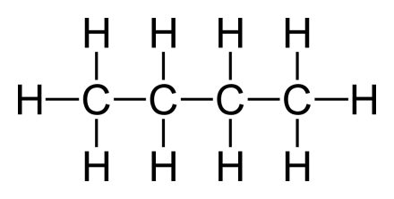
Pentane | 5

What is fractional distillation?
………………………………………………………………………………………………………………………………………………………………………………………………………………………………………………………………
What method can you use to separate liquids with different boiling points?
……………………………………………………………………………………
What is a boiling point?
………………………………………………………………………………………………………………………………………………………………………………………………………………………………………………………………
Draw a diagram of a fractionating column

Where do substances with high boiling points condense in the fractionating column?
………………………………………………………………………………………………………………………………………………………………………………………………………………………………………………………………
Where do substances with low boiling points condense in the fractionating column?
………………………………………………………………………………………………………………………………………………………………………………………………………………………………………………………………
Define the following words:
Viscosity
………………………………………………………………………………………………………………………………………………………………………………………………………………………………………………………………
Flammability
………………………………………………………………………………………………………………………………………………………………………………………………………………………………………………………………
How does the length of the carbon chain affect the following:
Boiling point
………………………………………………………………………………………………………………………………………………………………………………………………………………………………………………………………
Viscosity
………………………………………………………………………………………………………………………………………………………………………………………………………………………………………………………………
Flammability
………………………………………………………………………………………………………………………………………………………………………………………………………………………………………………………………
C1.4.3 Hydrocarbon Fuels
Complete the following equation for the combustion of hydrocarbons
Hydrocarbon + ……………. = ………………………+………………………

The following substance can be released when fossil fuels are burnt. Explain where they come from and the impact that they have on the environment
Carbon dioxide
Produced due to
………………………………………………………………………………………………………………………………………………………………………………………………………………………………………………………………
Impact on the environment
………………………………………………………………………………………………………………………………………………………………………………………………………………………………………………………………
Sulfur Dioxide
Produced due to
………………………………………………………………………………………………………………………………………………………………………………………………………………………………………………………………
Impact on the environment
………………………………………………………………………………………………………………………………………………………………………………………………………………………………………………………………
Carbon Monoxide
Produced due to
………………………………………………………………………………………………………………………………………………………………………………………………………………………………………………………………
Impact on the environment
………………………………………………………………………………………………………………………………………………………………………………………………………………………………………………………………
Oxides of Nitrogen
Produced due to
………………………………………………………………………………………………………………………………………………………………………………………………………………………………………………………………
Impact on the environment
………………………………………………………………………………………………………………………………………………………………………………………………………………………………………………………………
Particulates
Produced due to
………………………………………………………………………………………………………………………………………………………………………………………………………………………………………………………………
Impact on the environment
………………………………………………………………………………………………………………………………………………………………………………………………………………………………………………………………
Describe the causes and effects of acid rain
………………………………………………………………………………………………………………………………………………………………………………………………………………………………………………………………………………………………………………………………………………………………………………………………………………………………………………………………………………………………………………………………………………………………………………………………………………………………………………………………………………………………………………………………………………………………………………………………
Describe the causes and effects of global warming
………………………………………………………………………………………………………………………………………………………………………………………………………………………………………………………………………………………………………………………………………………………………………………………………………………………………………………………………………………………………………………………………………………………………………………………………………………………………………………………………………………………………………………………………………………………………………………………………
Describe the causes and effects of global dimming
………………………………………………………………………………………………………………………………………………………………………………………………………………………………………………………………………………………………………………………………………………………………………………………………………………………………………………………………………………………………………………………………
How are biofuels produced?
………………………………………………………………………………………………………………………………………………………………………………………………………………………………………………………………
C1.5 Other Useful Substances from Crude Oil
C1.5.1 Obtaining useful substances from crude oil
What is cracking and why is it necessary?
………………………………………………………………………………………………………………………………………………………………………………………………………………………………………………………………
Describe the process of cracking?
…………………………………………………………………………………………………………………………………………………………………………………………………………………………………………………………………………………………………………………………………………………………………………………………………………………………………………
What is the general formula for an alkene?
……………………………………………………………………………………
What happens when alkenes react with bromine water?
………………………………………………………………………………………………………………………………………………………………………………………………………………………………………………………………

Alkene | Number of Carbons | Number of Hydrogens | Formula | Structure
 | 1
 |  | 4
 |  |  | C₃H₆
Butene |  |  |  | 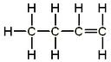
Pentene | 5

C1.5.2 Polymers
Draw a diagram representing the process of polymerisation of ethene. Label the following:
Monomer Polymer Ethene Poly(ethene)

Describe the process of polymerisation.
………………………………………………………………………………………………………………………………………………………………………………………………………………………………………………………………
What uses do we have for polymers?
………………………………………………………………………………………………………………………………………………………………………………………………………………………………………………………………
Why is it important to recycle polymers?
………………………………………………………………………………………………………………………………………………………………………………………………………………………………………………………………………………………………………………………………………………………………………………………………………………………………………………………………………………………………………………………………………………………………………………………………………………………………………………………………………………………………………………………………………………………………………………………………
C1.5.3 Ethanol
What are the two methods of producing ethanol?
………………………………………………………………………………………………………………………………………………………………………………………………………………………………………………………………
What are the advantages and disadvantages of each method?
………………………………………………………………………………………………………………………………………………………………………………………………………………………………………………………………………………………………………………………………………………………………………………………………………………………………………………………………………………………………………………………………

C1.6 Plant Oils and Their Uses
C1.6.1 Vegetable Oils
What steps are required to extract oils from fruits, seeds and nuts?
………………………………………………………………………………………………………………………………………………………………………………………………………………………………………………………………
How is olive oil extracted?
………………………………………………………………………………………………………………………………………………………………………………………………………………………………………………………………
Why are vegetable oils important foods?
………………………………………………………………………………………………………………………………………………………………………………………………………………………………………………………………
C1.6.3 Emulsions
What is an emulsifier?
………………………………………………………………………………………………………………………………………………………………………………………………………………………………………………………………
What is an emulsion? ………………………………………………………………………………………………………………………………………………………………………………………………………………………………………………………………
Why are emulsions useful?
………………………………………………………………………………………………………………………………………………………………………………………………………………………………………………………………
Higher Tier – What is meant by hydrophobic and hydrophilic?
………………………………………………………………………………………………………………………………………………………………………………………………………………………………………………………………
C1.6.3 Saturated and Unsaturated Oils
How do you test for the presence of a double bond?
………………………………………………………………………………………………………………………………………………………………………………………………………………………………………………………………
The presence of a double bond means that oil is Saturated/unsaturated. (Delete as appropriate)
Higher Tier – How can unsaturated oils be hardened? Describe the properties of the product.
………………………………………………………………………………………………………………………………………………………………………………………………………………………………………………………………………………………………………………………………………………………………………………………………………………………………………………………………………………………………………………………………
C1.7 Changes in the Earth and its Atmosphere
C1.7.1 The Earth’s Crust
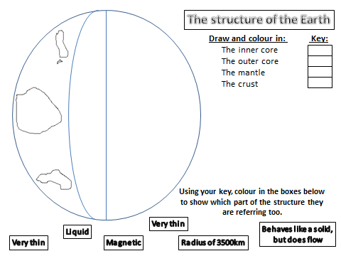
How do earthquakes and volcanoes occur?
………………………………………………………………………………………………………………………………………………………………………………………………………………………………………………………………………………………………………………………………………………………………………………………………………………………………………………………………………………………………………………………………

Explain why Wegener’s theories of crustal movement were not accepted for many years?
………………………………………………………………………………………………………………………………………………………………………………………………………………………………………………………………
Explain why scientists cannot accurately predict when earthquakes and volcanic eruptions will occur?
………………………………………………………………………………………………………………………………………………………………………………………………………………………………………………………………
Higher Tier – Describe why we do not know how life was first formed?
………………………………………………………………………………………………………………………………………………………………………………………………………………………………………………………………………………………………………………………………………………………………………………………………………………………………………………………………………………………………………………………………

C1.7.2 The Earth’s Atmosphere
Label the diagram to show the proportions of different gases in the atmosphere:
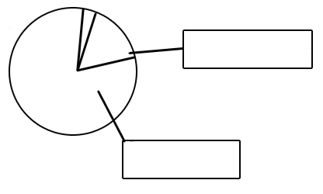
What was responsible for the formation of the Earth’s early atmosphere and provided the water that formed the oceans?
………………………………………………………………………………………………………………………………………………………………………………………………………………………………………………………………

What process produced the oxygen that is now in the atmosphere?
………………………………………………………………………………………………………………………………………………………………………………………………………………………………………………………………
What happened to a lot of the carbon dioxide that was in the air?
………………………………………………………………………………………………………………………………………………………………………………………………………………………………………………………………
What human activities have caused a change in our atmosphere?
………………………………………………………………………………………………………………………………………………………………………………………………………………………………………………………………
Higher Tier – What process could be used to separate the mixture of gases that makes up air?
………………………………………………………………………………………………………………………………………………………………………………………………………………………………………………………………

Self-Assess
The topics that I know in detail are:

The topics that I know but need to do some revision for are:

The topics that I do not understand and need to ask for help with are:

Other revision activities that you can now do are:
- Attend revision sessions on Friday
- Complete BBC bitesize activities
- Make revision cards
- Draw mind-maps
- Use AQA website to find practice questions

